### Arms & Hands:

The arms and hands were next, after some research I decided to use the same tools and methods I had used to create the facial features. I made both sides of the arms into a six sided face and then extruded these outwards evenly. At the end of each extruded arm I used the scale and connect tools to create the foundations of the hands.

To create the hands the extrude tool was once again used for the thumb and mitten looking hand, after which extra segments for the shoulders and elbows where created using the connect tool.

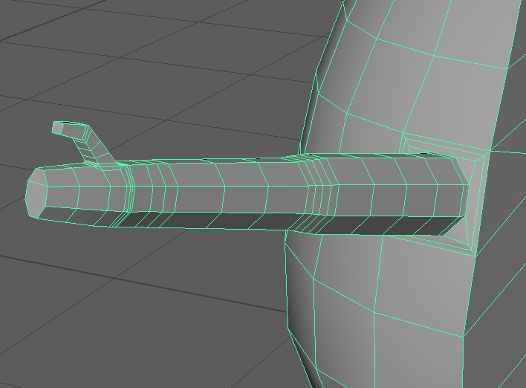This process is shown below on figures 12 & 13.

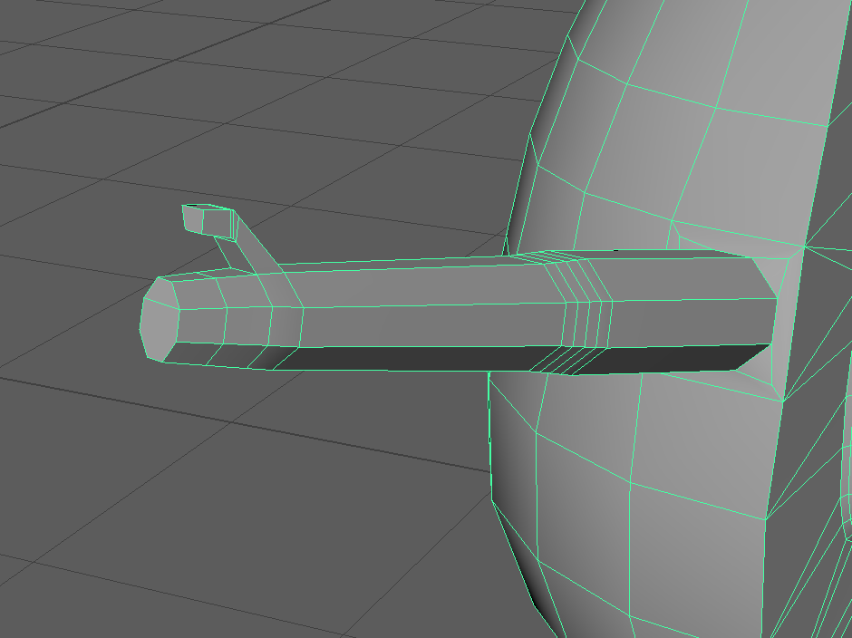

Figures 12, 13

At this stage of the process the group’s animator decided that the arms would need further modification to fit in with their animation processes, which they completed themselves.

# Customisation Assets:

For my role as game designer, I was tasked with creating customisation assets for the avatar. So the player could make it their own, thus bringing in more gamification and nurturing to the game. The assets I chose to create where a pair of sun glasses and a cap.

### Sunglasses:

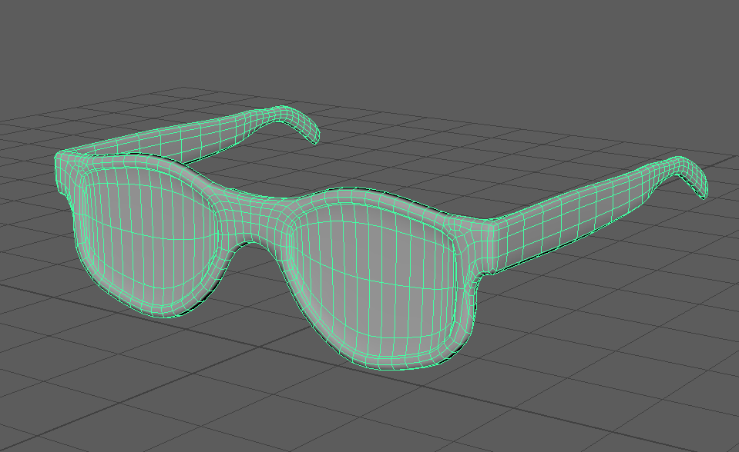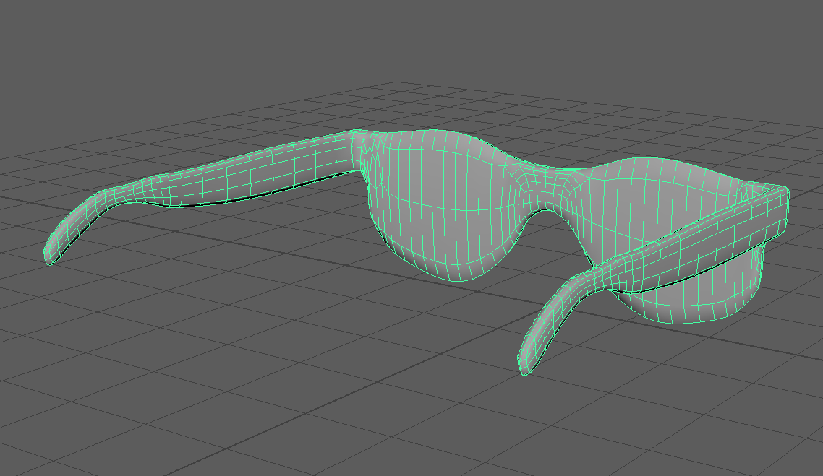The sunglasses were designed using the same methods of extruding, scale, connect, soft selection and smoothing tools. However in order to improve the accuracy of each side of the model and to ensure they were symmetric, I used the snap to vertex tool and the “local translate Z” option under the extruding tool. This ensured the result was symmetric, after which it was finished off using the smoothing tool. Results are shown on figures 14 & 15 below (Pretavoir 2020).

Figures 14, 15

### Cap / Snapback:

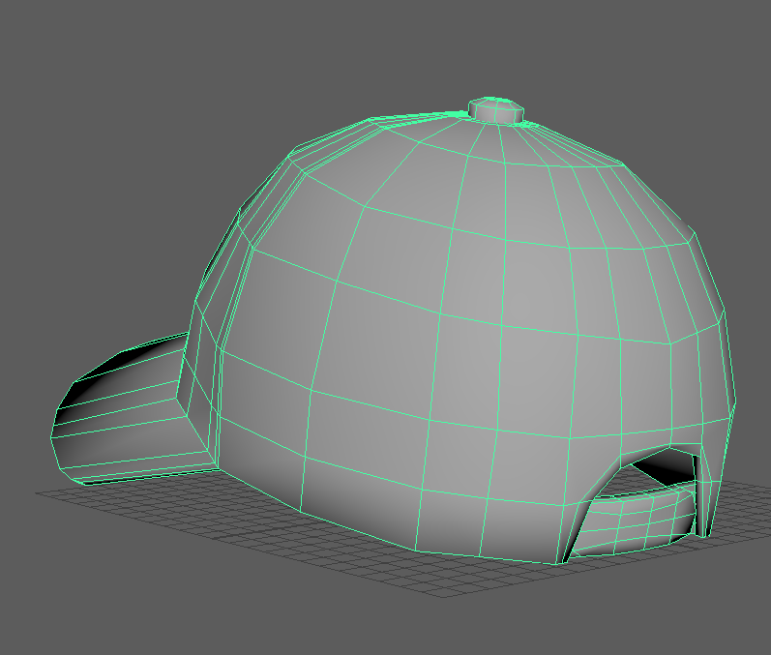The cap or snapback was designed using the same methods of extruding, scale, connect, soft selection and smoothing tools. However in order to add the extra details on the back of the cap such as the hole and strap, I used the multi cut tool which allowed me to add free handed segments to the model. I used this tool to add the top rounded area of the cap as well as the hole at the back after deleting the faces and using the bridge tool to bridge the faces on the outer parts of the hole. The results are shown on figures 16 & 17 (KG, A 2020).

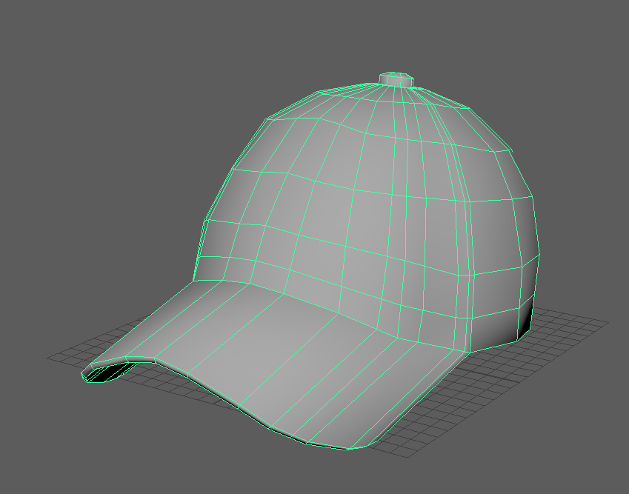

Figures 16, 17